WG145-1 DATA SHEET
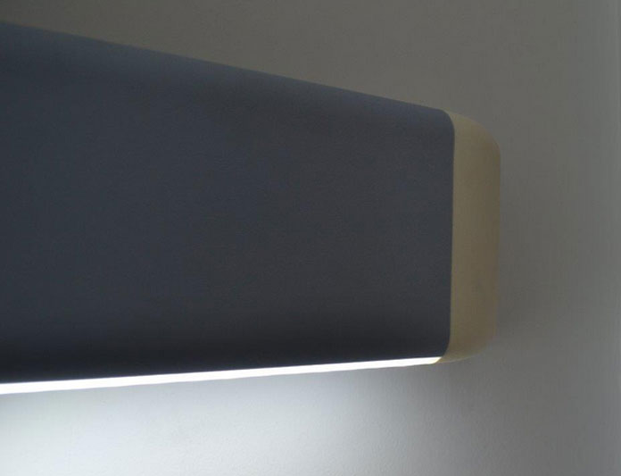
HANDRAIL WALL PROTECTION SYSTEM
-145 mm Height
-45 mm Wall Offset
-2 mm thick ARFEN Vinyl Cover
-ARFEN Vinyl Decorative Bracket
-Continuous Aluminium Retainer
-Reinforced with TPE insert
Specifications:
-Impact Resistance
-Fire Resistance
-Antibacterial PVC Cover
-Perfect patterned ARFEN right and left return accessories; WG006 & WG005
-Perfect patterned ARFEN internal and external corner accessories; WG007-1 & WG007-2

